**1 -DOWNLOAD AND INSTALL POSTRESQL**

https://www.postgresql.org/download/

download the installer

you might want to block your firewall if you cannot start downloading

while installing

provide a password!!!

dont forget, if you forget, you will need to UNINSTALL AND REINSTALL!

write 5432 for port number

wait until its finished

**2 - NOW DOWNLOAD AND INSTALL PGADMIN**

Use pgadmin 3 only if you have an old computer(windows 7), prefereably go for **pgadmin4**

Download the latest version, download .exe file

Use it as *Administrator*

**3 – dvdrental file**

Use the provided database file: dvdrental.tar ( you will find this in your course materials)

**4- Restart the computer**

Restart after installation of pgadmin and postgresql

**5- Restore the DB**

If you see exit code or something ignore it

Create your db and name it, do not do anything else

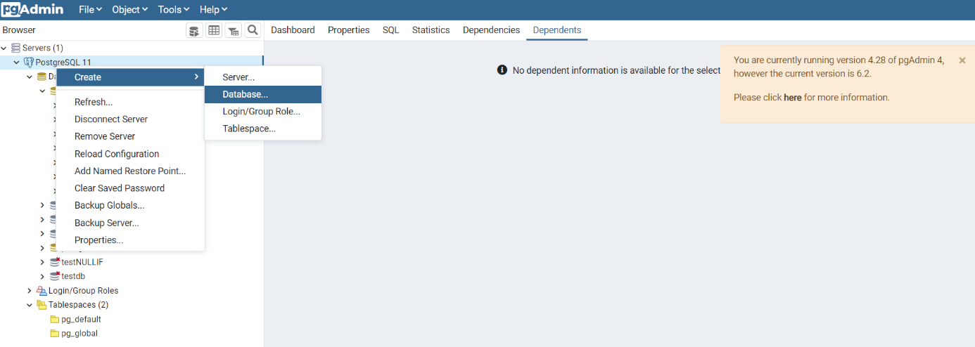

**Now restore the db**

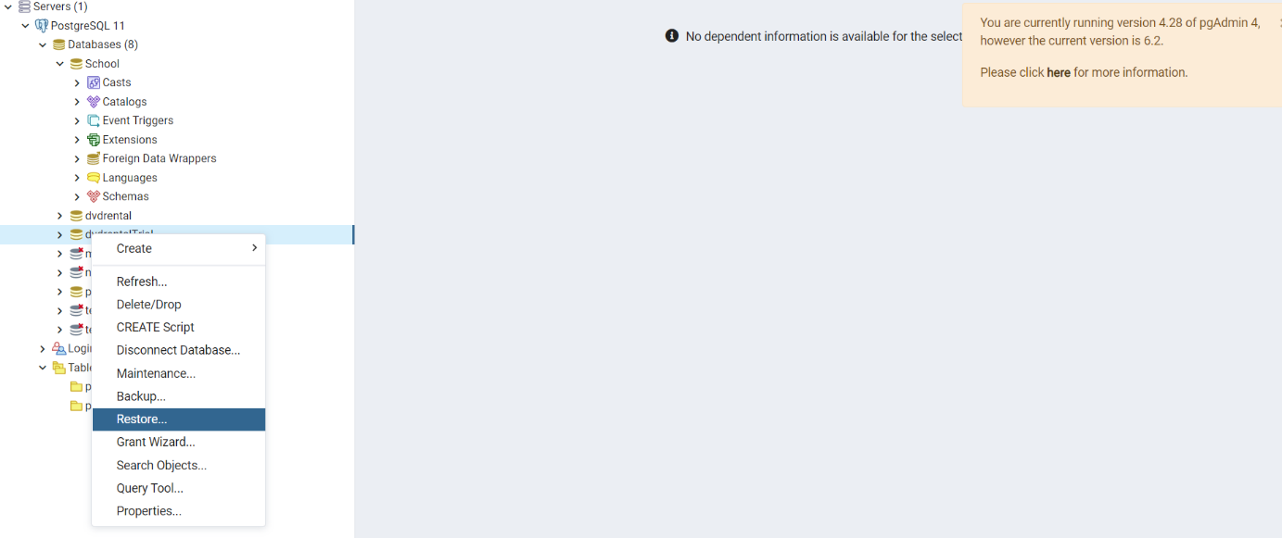

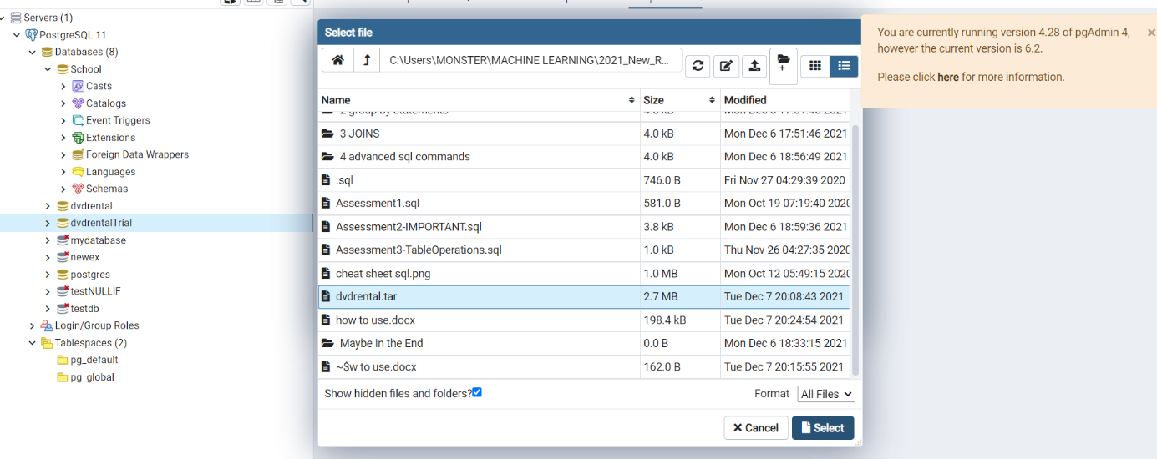

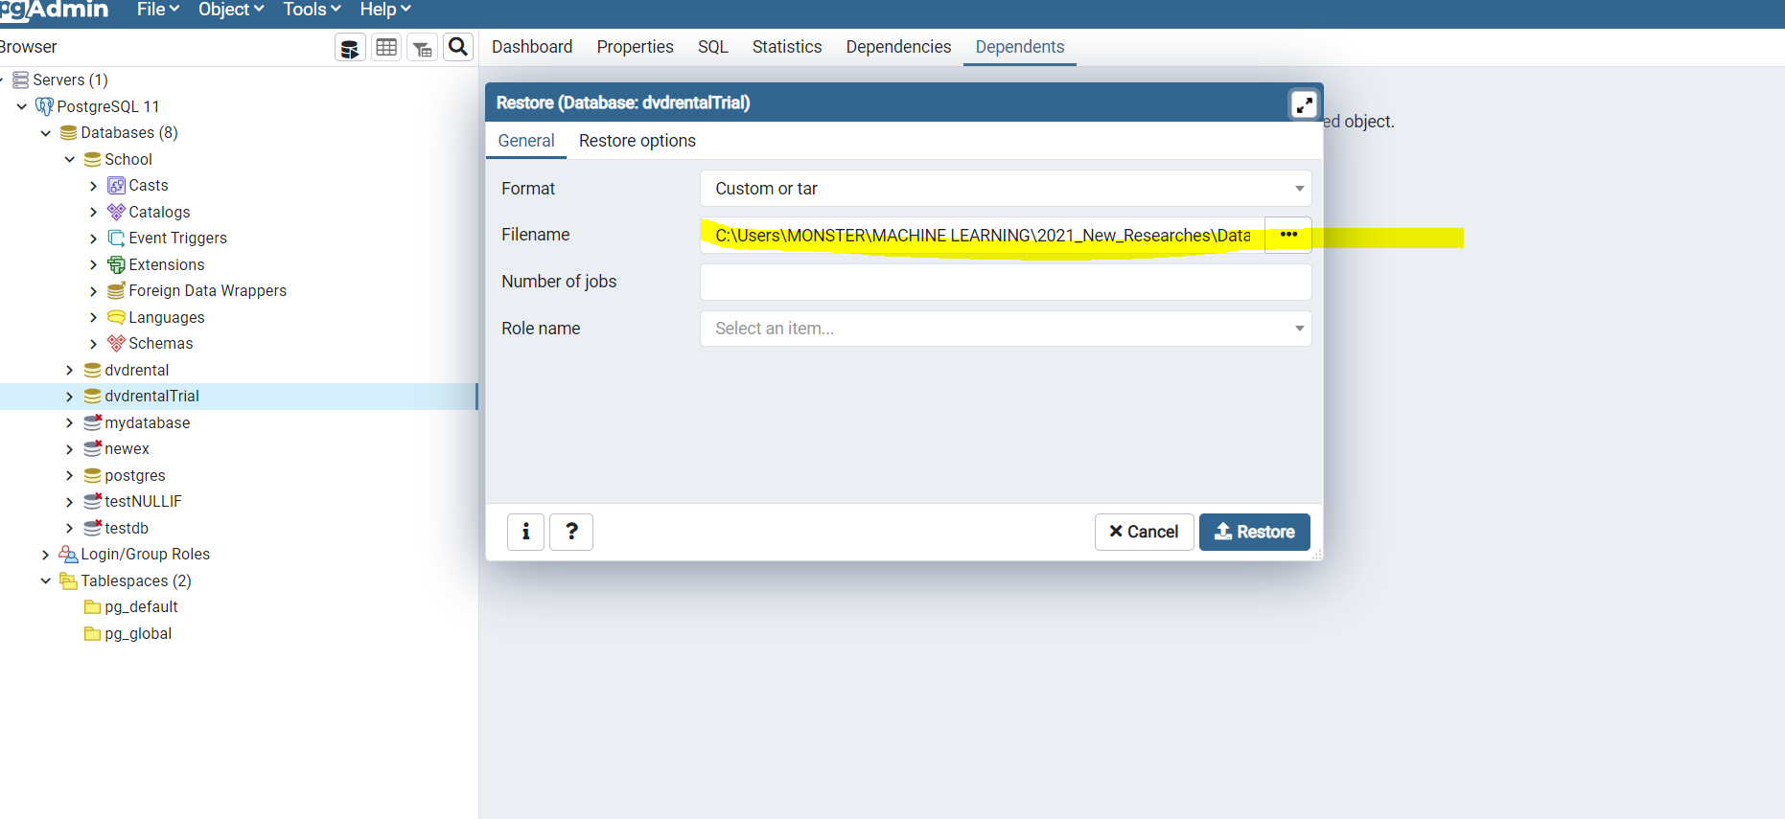

Open restore options and do this below and leave everything else:

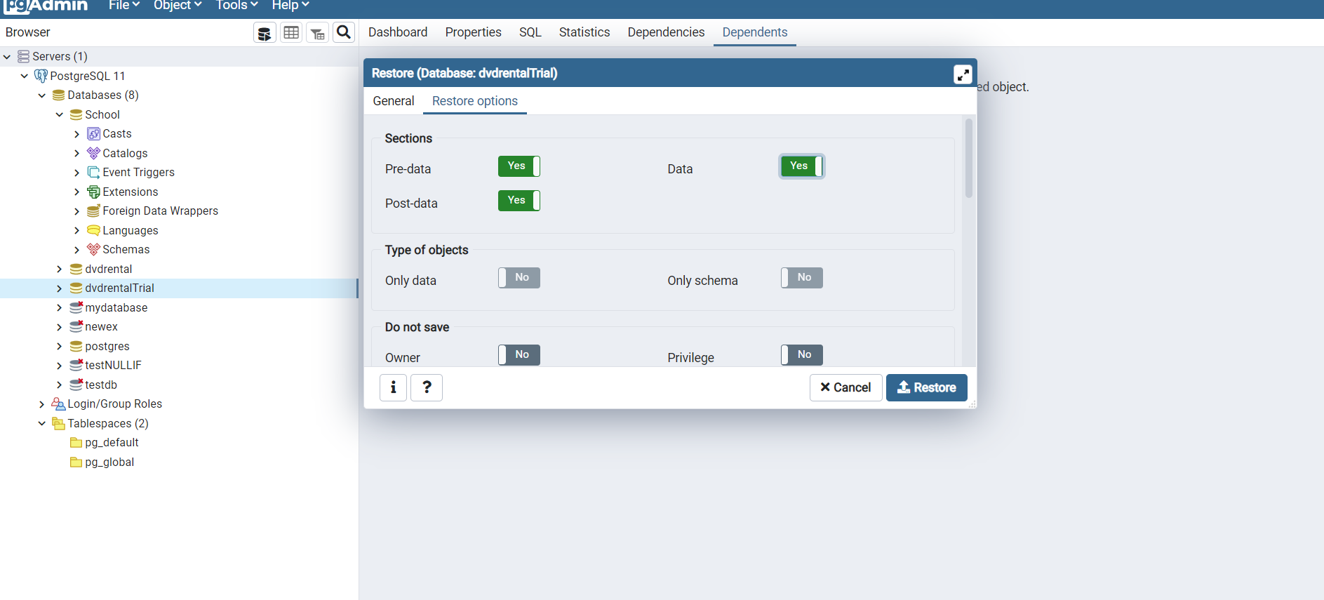

İf you get failed exit code, dont worry

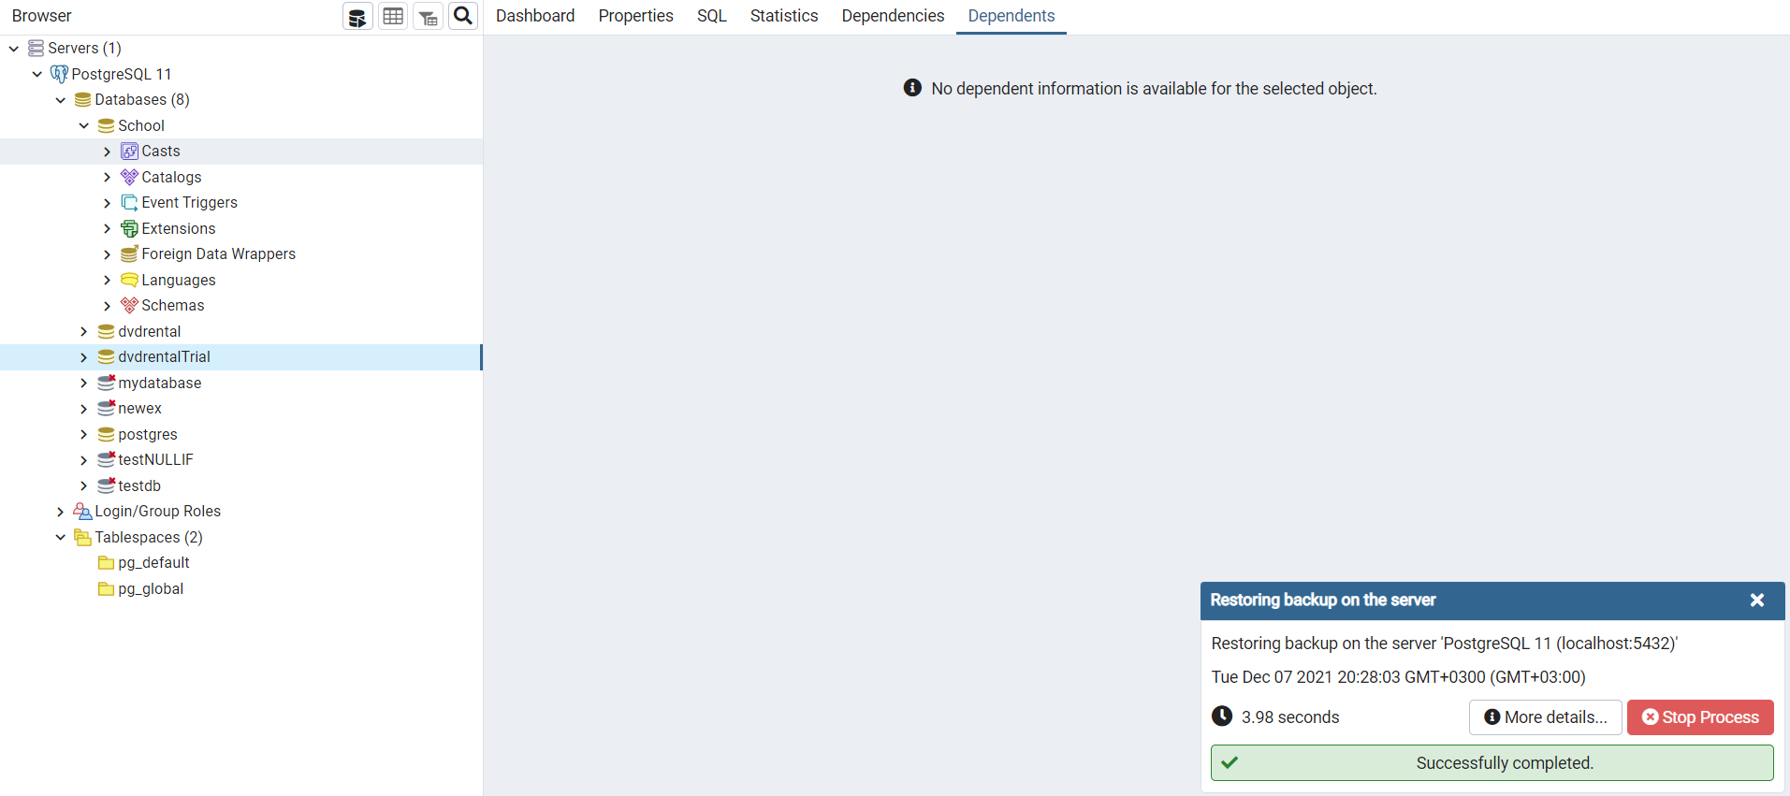

Refresh once you finished those steps

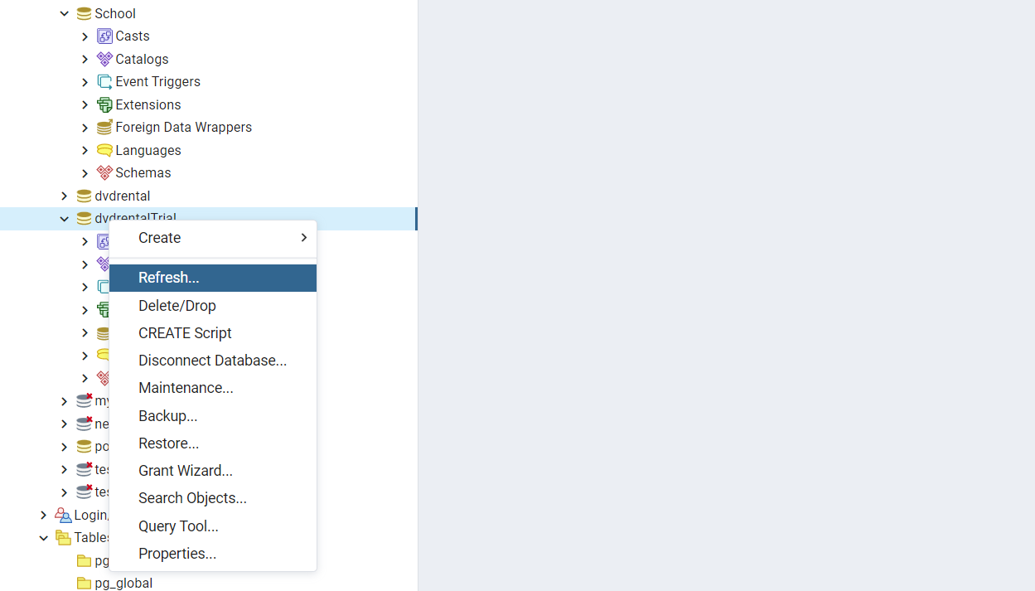

Go to Query tool ( we will use this part for the course all the time)

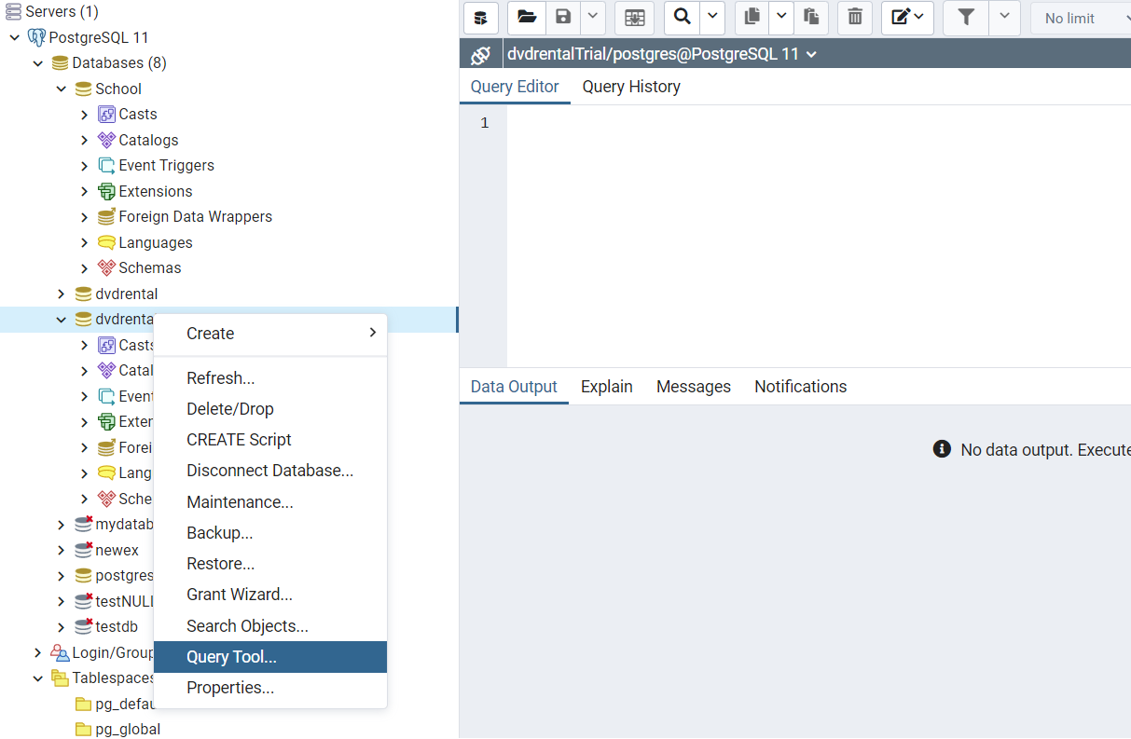

Write the most basic query in SQL history ` select * from film` if you see this screen THEN YOU ARE READY. GOOD JOB

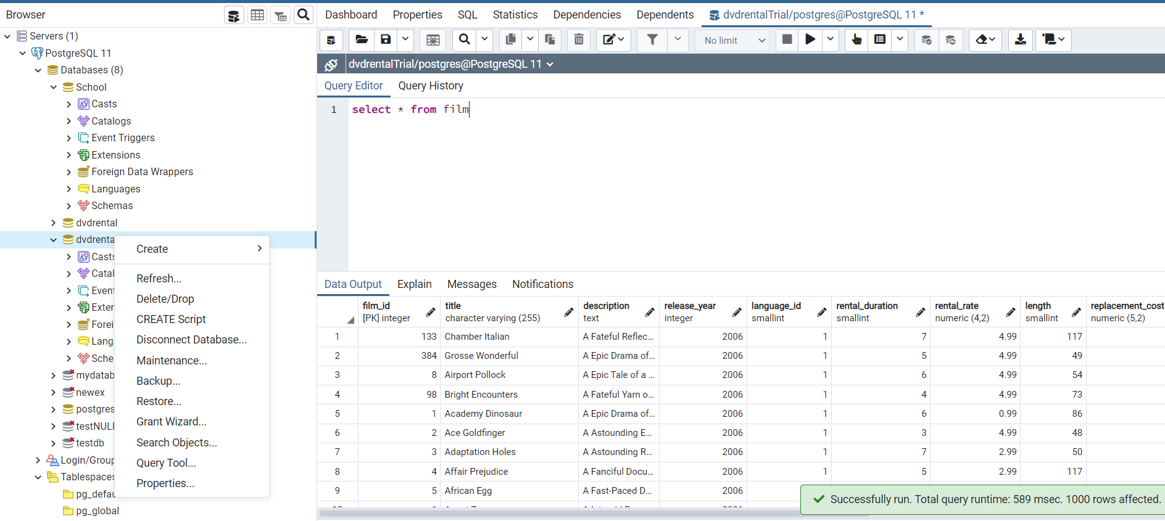

Choose the database and right click

Choose Query Tool